Experiment No: 04

Aim
To design and deploy a Payroll Processing System on Zoho Creator to demonstrate Software as a Service (SaaS), where employee payroll details are managed online and Gross Pay/Net Pay are calculated automatically.

Procedure
- Step 1: Login to Zoho Creator using your Zoho account.
- Step 2: Create a new application named 'Payroll Processing System'.
- Step 3: Create a form with fields: Employee Name, Field Experience, Overall Experience, Basic Pay, HRA, DA, TA, Gross Pay, Employee ID, Net Pay.
- Step 4: Create a workflow to calculate Gross Pay using: input.Gross = input.Basic_Pay + input.HRA + input.DA + input.TA;
- Step 5: Create a report to display all employee payroll details.

Payroll Processing SaaS Application
Figure 1: Payroll Processing Form
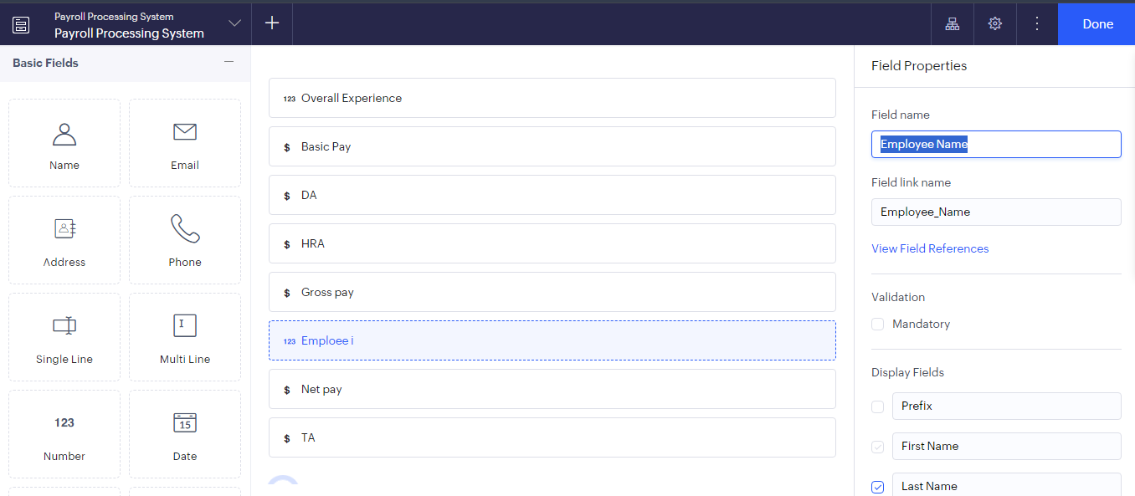
Figure 2: Form Builder
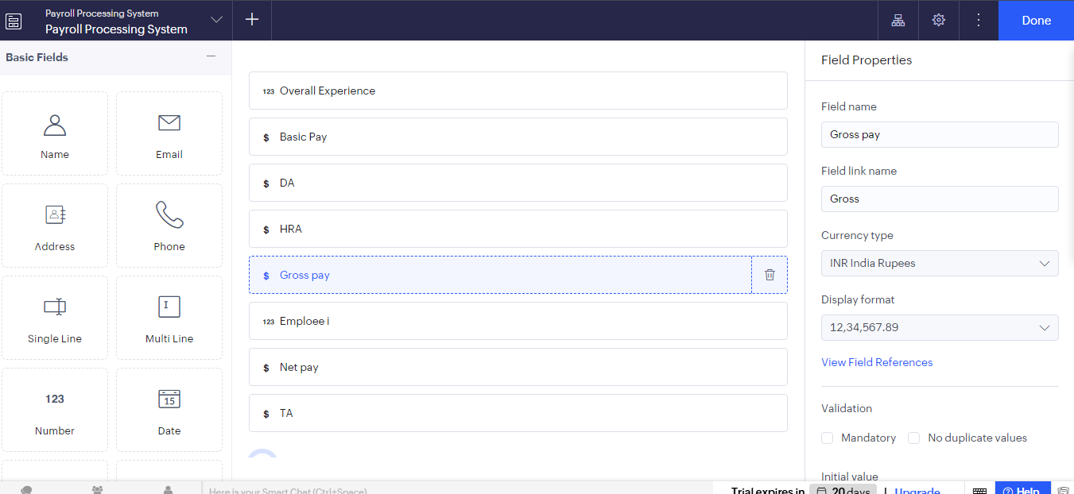
Figure 3: Gross Pay Field
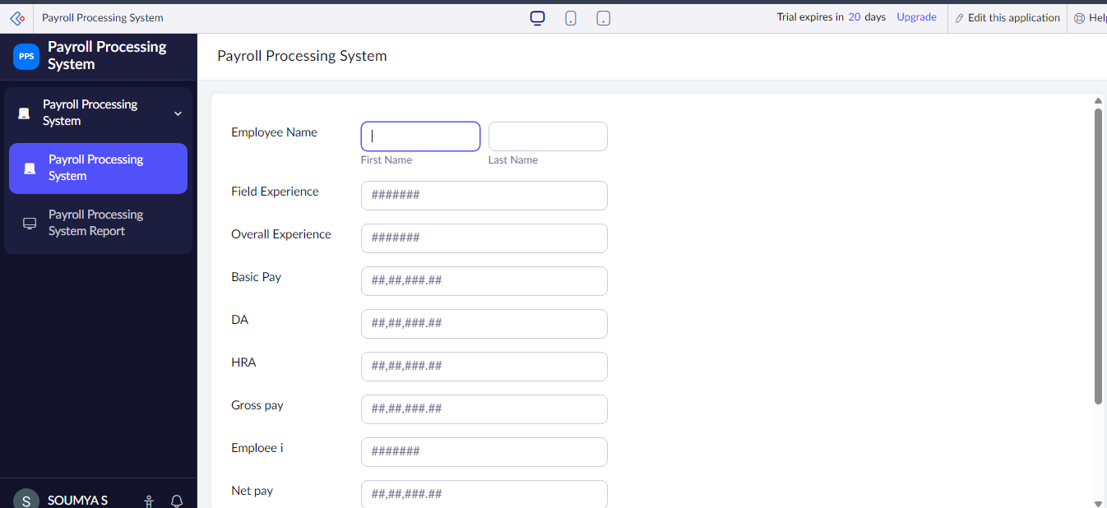
Figure 4: Gross Pay Workflow
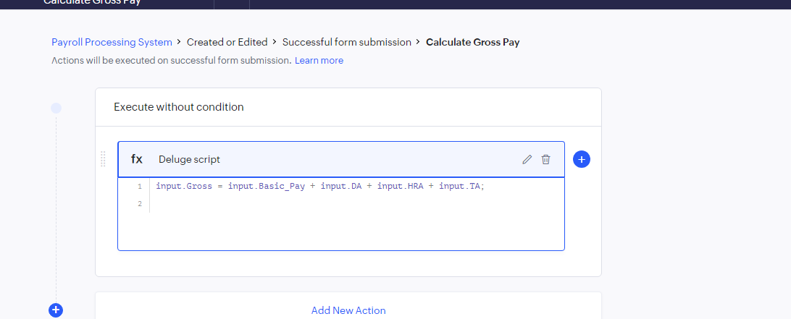
Figure 5: Payroll Report
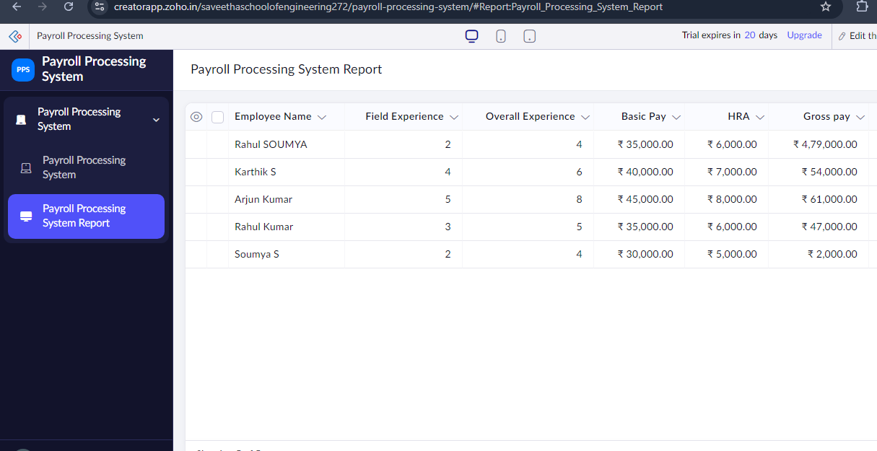

Result
A Payroll Processing SaaS application was successfully created using Zoho Creator. Employee payroll information is stored online, Gross Pay is calculated automatically through workflow, and reports display employee salary details. The application is accessible through the cloud, demonstrating the SaaS model.

